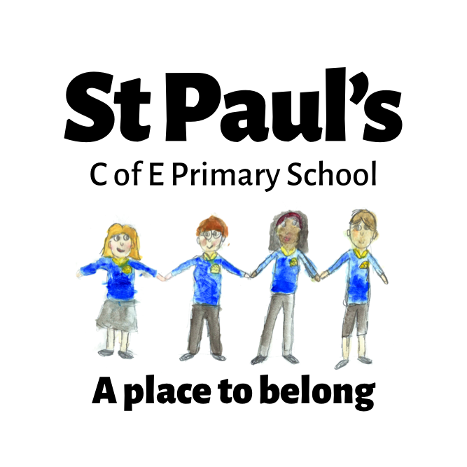

Our Vision Driven RE Curriculum

At St Paul’s, our vision “A Place to Belong” underpins all that we do. As a school family, we are committed to ensuring that every child feels safe, valued and supported to flourish as a unique individual. In line with our Christian foundation and our strapline, Religious Education plays a vital role in helping us to live out our vision and in preparing our children for life in the 21st century.
Our RE curriculum is designed to develop compassionate, thoughtful and reflective learners who appreciate and respect the rich diversity of belief and practice in our school, our community and the wider world. As our community continues to grow and change, becoming increasingly diverse, our curriculum reflects this by covering Christianity alongside a range of world religions and worldviews, including humanist and non-religious beliefs.
Each lesson children are reminded that RE allows us to explore our beliefs, values and traditions and those of others.Through RE, we aim to ensure that children become religiously literate and that all children are able to understand, discuss and question beliefs with sensitivity and respect. We want our pupils to develop the skills and confidence to recognise both shared values and differences, and to celebrate the contribution that a variety of faiths and worldviews make to society.
Rooted in our Christian ethos and inspired by Romans 12:5-8 – “Though we are many, we form one body, all joined together as members of the whole. We each have different gifts, according to the grace given to each of us” – our RE curriculum helps children see the importance of belonging, connection, and using their gifts to make a positive difference in the world.
In doing so, we prepare our pupils not only to achieve their full potential academically, but also to grow as compassionate, open-minded and caring individuals who will carry a life-long love of learning, respect for others, and readiness to contribute to their futures in a global society.

RE LTP - York Syllabus
EYFS,KS1, KS2
2026-2027

 | Autumn Term |  |  | Spring Term |  | Summer Term
EYFS | F5: Where do we belong?  Christians, Hindus and Muslims | F4: Which times are special and why?  Christians, Hindus, and Jewish people |  | F6: What is special about our world?  Christians, Muslims, and Jewish people | F2: Which people are special and why?  Christians, Muslims, and Jewish people | F3: What places are special and why?  Christians and Muslims
EYFS | F1: Which stories are special and why?  Christians, Hindus and Muslims
Year 1 | 1.1 Who is Christian and what do they believe? (part 1)  Christians | 1.6 How and why do we celebrate special and sacred times? (Part 1)  Christians, Muslims, or Jewish people |  | 1.2 Who is a Muslim and what do they believe? (part 1)  Muslim | 1.7: What does it mean to belong to a faith community?  Christians, Muslims, and Jewish people | 1.5: What makes some places sacred?  Christians, Muslims, and/or Jewish people
Year 2 | 1.6 How and why do we celebrate special and sacred times? (Part 1)  Christians, Muslims, or Jewish people | 1.1 Who is Christian and what do they believe? (part 1/2)  Christians |  | 1.6 How and why do we celebrate special and sacred times? (Part 2)  Christians, Muslims, or Jewish people | 1.4 What can we learn from sacred books?  Christians, Muslims, and Jewish people | 1.2 Who is a Muslim and what do they believe? (part 1)  Muslims | 1.2 Who is a Muslim and what do they believe?  (Part 2)
Year 3 | 2.7 What does it mean to be a Christian in Britain today? (part 1)  Christians |  | L2.8 What does it mean to be Hindu in Britain today? (part 1)  Hindus | L2.2 Why is the Bible so important for Christians today?  Christians | L2.5 Why are festivals important to religious communities?  Easter, Eid focus | L2.1 What do different people believe about God?  Hindus, Christians and Muslims | L2.4 Why do people pray?  Christians, Hindus or Muslims
Year 4 | L2.8 What does it mean to be Hindu in Britain today? (part 2)  Hindus | L2.5a How do people from religious and non - religious communities celebrate key festivals?  Christians and non - religious people (with a probable focus on another religion - Judaism) |  | L2.7 What does it mean to be a Christian in Britain today? (part 2)  Christians | L2.3 Why is Jesus inspiring to some people?  Christians | L2.9 What can we learn from religions about what is right and wrong?  Christians, Jewish people and non - religious people (Humanist) | L2.6 Why do some people think that life is a journey? What significant  experiences mark this?  Christians, Hindus and/or Jewish people
Year 5 | U2.1 Why do some people believe God exists?  Christians, non - religious people (Humanist) | U2.6 What does it mean to be a Muslim in Britain today? (part 1)  Muslim |  | U2.7 What matters most to Christians and Humanists?  Christians, non - religious people (Humanist) | U2.2 What would Jesus do? (Can we live by the values of Jesus in the twenty-first century?)  Christians | U2.4 If God is everywhere, why go to a place of worship?  Christians, Hindus and Jewish people | U2.10 Green religion?  How and why should religious communities do more to care for the Earth?  Christians, Hindus and/or Jewish people
Year 6 | U2.1 Why do some people believe God exists?  Christians, Muslims, non-religious ideas | U2.9 What can be done to reduce racism? Can religion help?  Christians, Muslims, non-religious ideas |  | U2.5 Is it better to express your beliefs in arts and architecture or in charity and generosity?  Christians, Muslims, non-religious (Humanist) |  | U2.3 What do religions say to us when life gets hard?  Christians, Hindus and non-religious

Each unit covers one or more of the RE disciplines listed below, which will be clearly identified at the start of every lesson.

Key Disciplines |   Thinking |   Believing |   Living
Key Disciplines | This is about THINKING. It is about finding out how and whether things make sense. It deals with questions of morality and ethics. It takes seriously questions about reality, knowledge and existence.  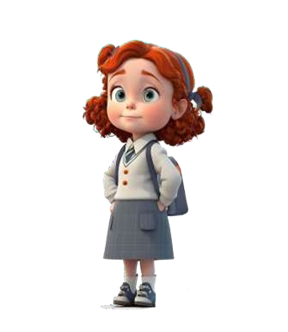 | This is about BELIEVING. It looks at where beliefs come from, how they have changed over time, how they are applied differently in different contexts and how they relate to one another.  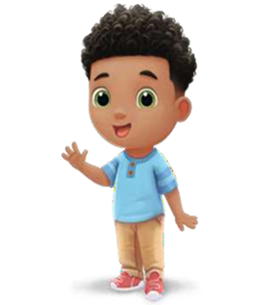 | This is about LIVING. It explores the diverse ways in which people practice their beliefs. It engages with the impact of beliefs on individuals, communities and societies.  

